Would you like to be more confident helping your child with their maths homework?
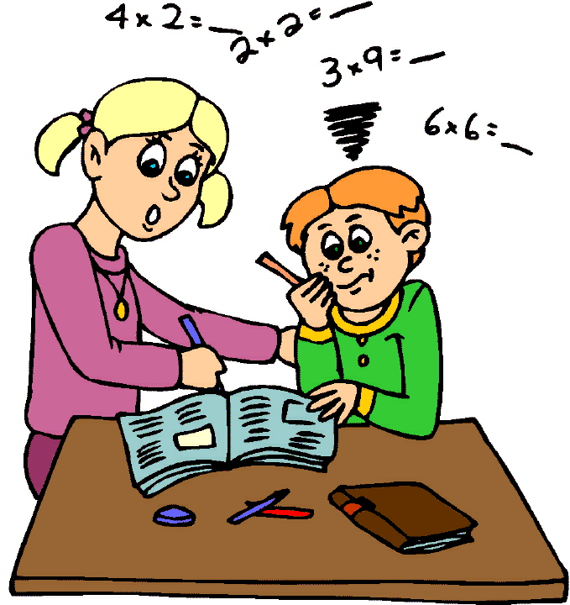

Every Tuesday 10-11 am in room 37
Contact Florence 0429376953 fgillan.bpp@lmetb.ie
Reviews from past/present parents who attended thisfriendly and informal class

"I found this class extremely good as it brought me back to the basic maths, which I had actually forgotten. The tutor is most informative and made me feel at ease." 2016

"I learned how to use the calculatormy children use today, as in my day the calculators were not as hi-tech as now, it's amazing how much the new calculators can do, a great help for our children"2018

"I am now no longer afraid of Algebra, this area of maths was like a foreign language to me but now I have a good insight and I can at least understand what my child is saying to me Thank you maths class BPP!" 2016

‘Miriam is a lovely calm presence who encourages and supports learning. Thanks to her help my confidence has soared.’ a grateful parent 2018

