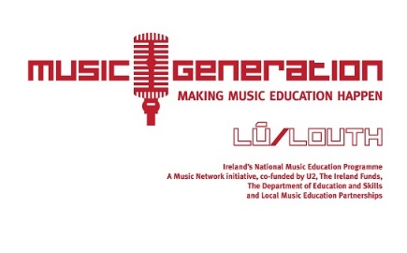

IMPORTANT NEWS! SCHOOLS TRAD ORCHESTRA GATHERING IN FEBRUARY AT FÉILE NA TÁNA!!
CALLING YOUNG MUSICIANS!!! SIGN UP NOW!

Music Generation Louth's Schools Trad Orchestra Collective was so successful last summer at Fleadh 2018 in Drogheda that we have decided to keep the project alive and have scheduled another workshop for the group next month!
WHEN AND WHERE!
Our workshop coincides with the wonderful Féile Na Tána Traditional Music Festival in Carlingford and takes place on Saturday 2 February, 2-5pm at Bush Post Primary School, Cooley.
It is free of charge and open to all the musicians who participated in our summer rehearsals and performance on the Gig Rig in Drogheda last August. We also welcome new musicians from our partner schools who have been playing strings for one year or longer.
Local musician Zoe Conway is once again working on a special arrangement of tunes for us to play. The plan is that we will schedule two further rehearsals over Easter holidays as well as meeting again in the summer to get the group super ready to perform at Fleadh 2019! More details to follow on that soon.
Féile Na Tána is a highlight event in the world of traditional music with performances and workshops by some of Ireland's finest musicians. We are thrilled to be part of the Festival this year. We are also delighted that the Festival is offering each young musician a festival pass meaning that they can attend all the performances for free; special discounted tickets for accompanying adults/family members (€5) also available. (I have enclosed a Féile Na Tána leaflet so you can read about everything else that is on over the weekend).
We really hope to see all the musicians who participated in Fleadh 2018 back for more and also hope to see lots of new faces too.
To register for the workshop, simply complete the form enclosed and return to your school Principal no later than Friday 25 January 2019. We will be in touch very shortly after that date with the final details.
Best regards

Gemma Murray

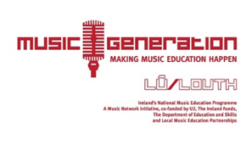

Registration Form

MGL SCHOOLS TRAD ORCHESTA WORKSHOP2 FEB 2019
Please return to your school Principal by Friday25 January 2019

Child’s Name: _________________________________
Child's Date of Birth: ________________________________
Details of any allergies, medical conditions, special needs:
__________________________________________________________
__________________________________________________________
__________________________________________________________
__________________________________________________________
Name of School: _________________________________
Instrument: _________________________________

Parent’s/Guardian’s Name: _________________________________
Parent’s/Guardian’s Mobile Tel No: _________________________________
Parent/Guardian’sEmail address: _________________________________

Please Tick as Appropriate:
I hereby give permission for my child to be photographed/recorded during this workshopwith the understanding that recordings may be used by Feile Na Tána, Music GenerationLouthand its lead partner organisations LMETBand Music Generation National Office for promotional purposes on Social Media and in the National and Local Press

I hereby do notgive permission for my child to be photographed/recorded during this workshop.

Sign me up to the Music Generation Louth Newsletter
Signature of Parent/Guardian_______________________________________________________

